**AUTHORITY TO DEDUCT-1**

**(Loan Monthly Amortization)**

I hereby authorize the company to deduct my monthly loan amortization from my salary, in accordance with my Loan Statement of Account/Disclosure Statement of Loan.

**LOAN DETAILS:**

|  |  |
| --- | --- |
| Type of Loan, pls specify  *(e.g. SSS- Salary Loan/ SSS Calamity Loan/*  *Pag-Ibig Salary Loan or MPL / Pag-Ibig Calamity Loan )* | SSS-Salary Loan |
| Monthly Amortization:  *(e.g. 1,753.51)* | 904.55 |
| First Monthly Amortization:  *(e.g. October 2022)* | DEC-2025 |

**Payroll Loan Setup Details:**

|  |  |
| --- | --- |
| Preferred MONTHLY Deduction Amount:  *(e.g. 1,755.00)* | **(NOTE: This amount should not be lower than the required monthly amortization as stated on the SOA.)** |
| 904.55 |
| Payroll Cut-off for Loan Deduction:  *(e.g. every payroll cut-off)* | (Pls specify if every 1st cut-off only; every 2nd cut off only; every payroll cut-off) |
| every 1st cut-off only |

|  |  |  |  |  |  |  |
| --- | --- | --- | --- | --- | --- | --- |
| Issued this | 3rd | day of | October | 20 | 25 | , in Makati City Philippines. |

|  |
| --- |
| Prepared by: |
| John Christian Alvarez |
| Employee Name  (Signature over Printed Name) |

|  |  |  |
| --- | --- | --- |
| **\*\*NOTE - Collection Periods:** | |  |
|  | ***SSS Loan -*** *The collection period is two years from the date of the first monthly amortization payment, as indicated on the Statement of Account (SOA). This first payment should be reflected as the first deduction on the employee's payroll.* | |
|  | ***Pag-Ibig Loan*** *- The collection period is two to three years, depending on the specific loan application. The first monthly amortization payment due, as shown on the SOA, represents the first remittance due to Pag-IBIG. Therefore, the first deduction from the employee's payroll should be one month in advance of the start of the amortization period shown on the SOA.* | |

**Page 1 of 4**

**“SSS Salary Loan / SSS Calamity Loan”**

Please see the snippet below for your reference:

**Page 2 of 4**

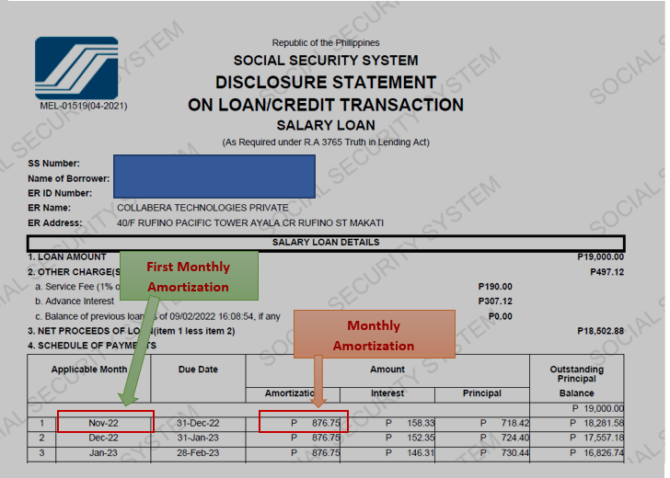

Please be guided by the terms and conditions below:

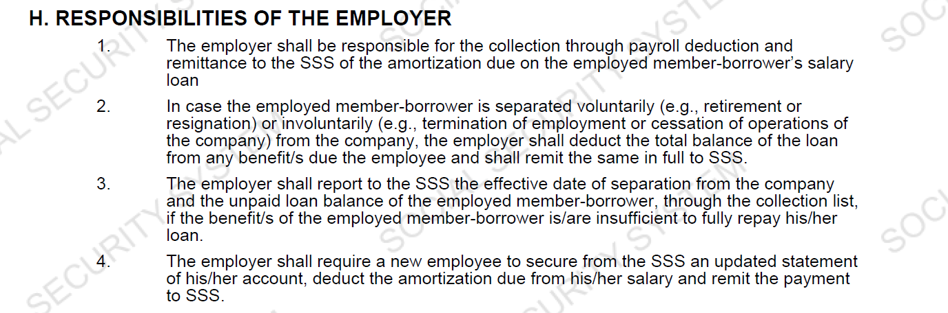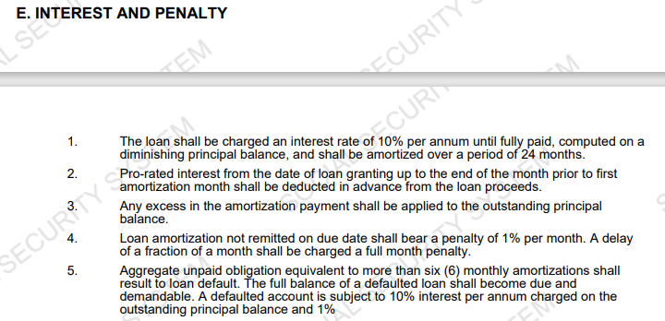

**“Pag-ibig Salary Loan / Pag-Ibig Calamity Loan” PART 1**

Please refer to the snippet below.

1. On the employer portal

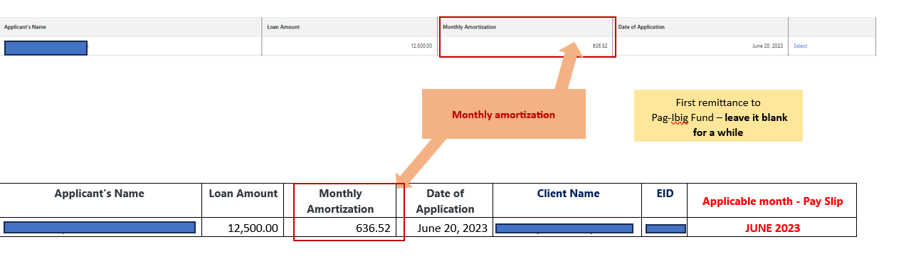

1. Virtual Pag-Ibig

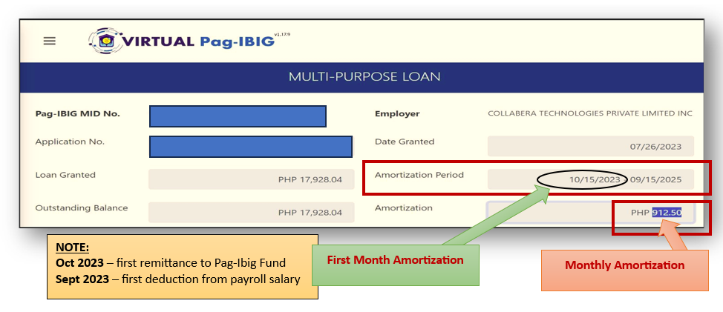

1. Pag-Ibig Fund notice/latest billing statement

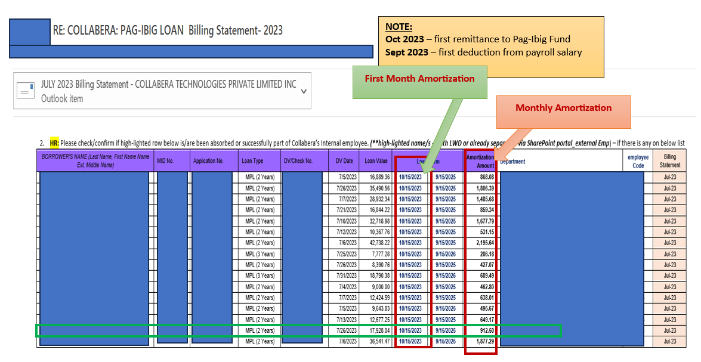

**Page 3 of 4**

**“Pag-ibig Salary Loan / Pag-Ibig Calamity Loan” PART 2**

Please be guided by the terms and conditions below:

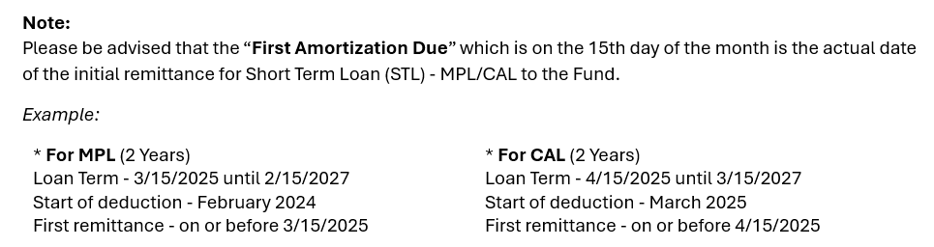

**Page 4 of 4**

